**Worksheet 20 - Dijkstra’s algorithm**

Find the shortest path from source to destination in each of the following graphs using Dijkstra’s algorithm. Give the shortest path from source to every other node in the graph. Also, give the routing table entries (destination, next hop pairs) at source.

**Graph 1:**



1. Source = A
2. Source = D

**Graph 2:**

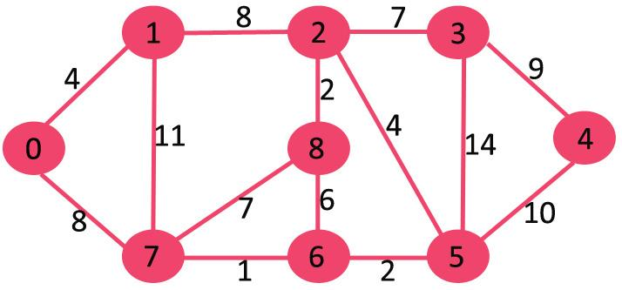

1. Source = 0
2. Source = 8

**Graph 3:**

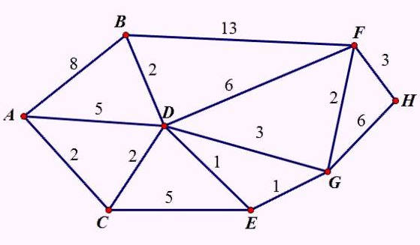

1. Source = A
2. Source = D

**Graph 4:**

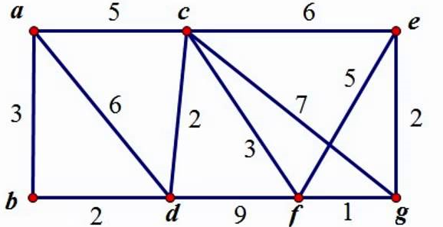

1. Source = a
2. Source = f